**NAME :** SREYA G **REGISTER NO.:** 230701334

**CLASS :** CSE F **DATE:** 01/08/2024

**EX-1:**

**BASIC C PROGRAMMING:**

PROBLEM 1:

AIM:

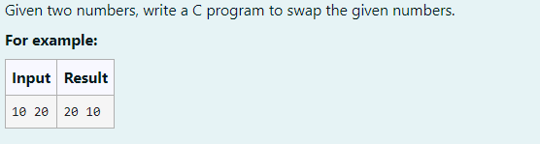

ALGORITHM:

1. Input two integers a and b.

2. Store a in a temporary variable temp.

3. Assign the value of b to a.

4. Assign the value of temp (original a) to b.

5. Output the swapped values of a and b.

CODE:

#include<stdio.h>

int main()

{

int a,b,temp;

scanf("%d",&a);

scanf("%d",&b);

temp =a;

a = b;

b = temp;

printf("%d ",a);

printf("%d",b);

}

OUTPUT:

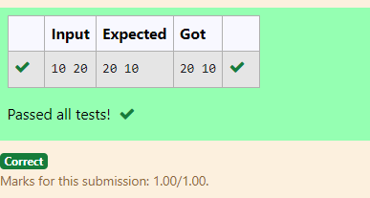

RESULT:

Thus the code is executed successfully and gives the expected output.

PROBLEM 2:

AIM:

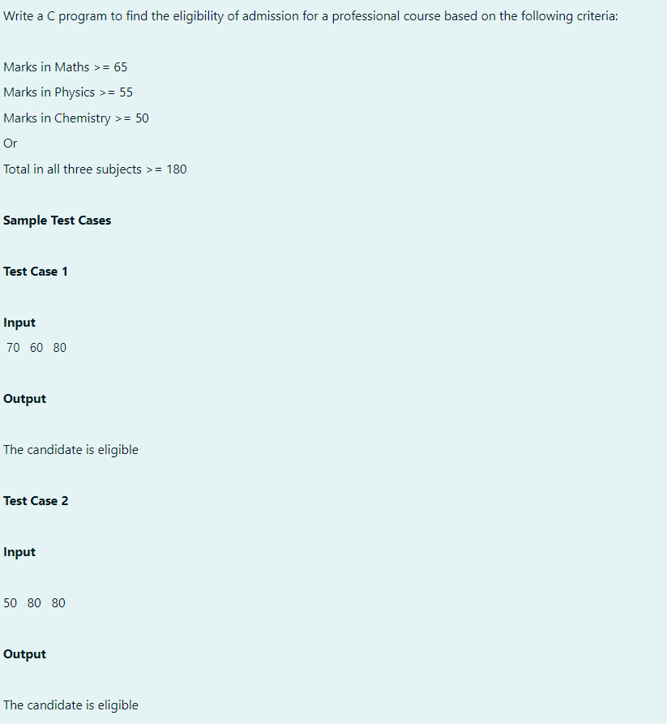

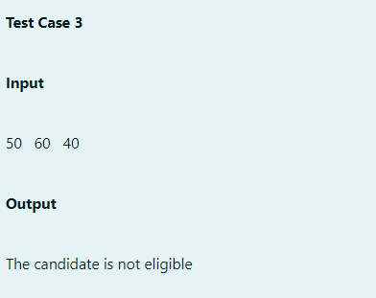

ALGORITHM:

1. Input the marks for maths,physics, and chemistry.

2. Calculate the total marks by adding maths, physics, and chemistry.

3. Check eligibility:

- If maths >= 65, physics >= 55, and chemistry >= 50, the candidate is eligible.

- Else if the total marks are greater than or equal to 180, the candidate is eligible.

4. Output eligibility status: Print "The candidate is eligible" or "The candidate is not eligible".

CODE:

#include<stdio.h>

int main()

{

int maths,physics,chemistry;

int total;

scanf("%d",&maths);

scanf("%d",&physics);

scanf("%d",&chemistry);

total = maths + physics + chemistry;

if(maths >= 65 && physics >= 55 && chemistry >= 50)

{

printf("The candidate is eligible");

}

else if(total >= 180)

{

printf("The candidate is eligible");

}

else

{

printf("The candidate is not eligible");

}

}

OUTPUT:

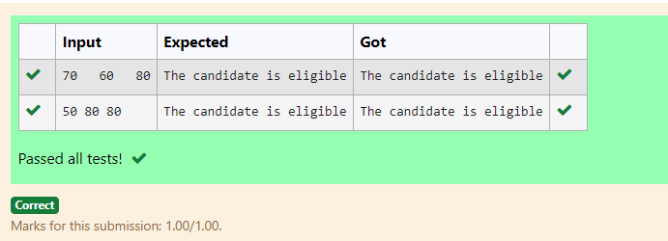

RESULT:

Thus the code is executed successfully and gives the expected output.

PROBLEM 3:

AIM: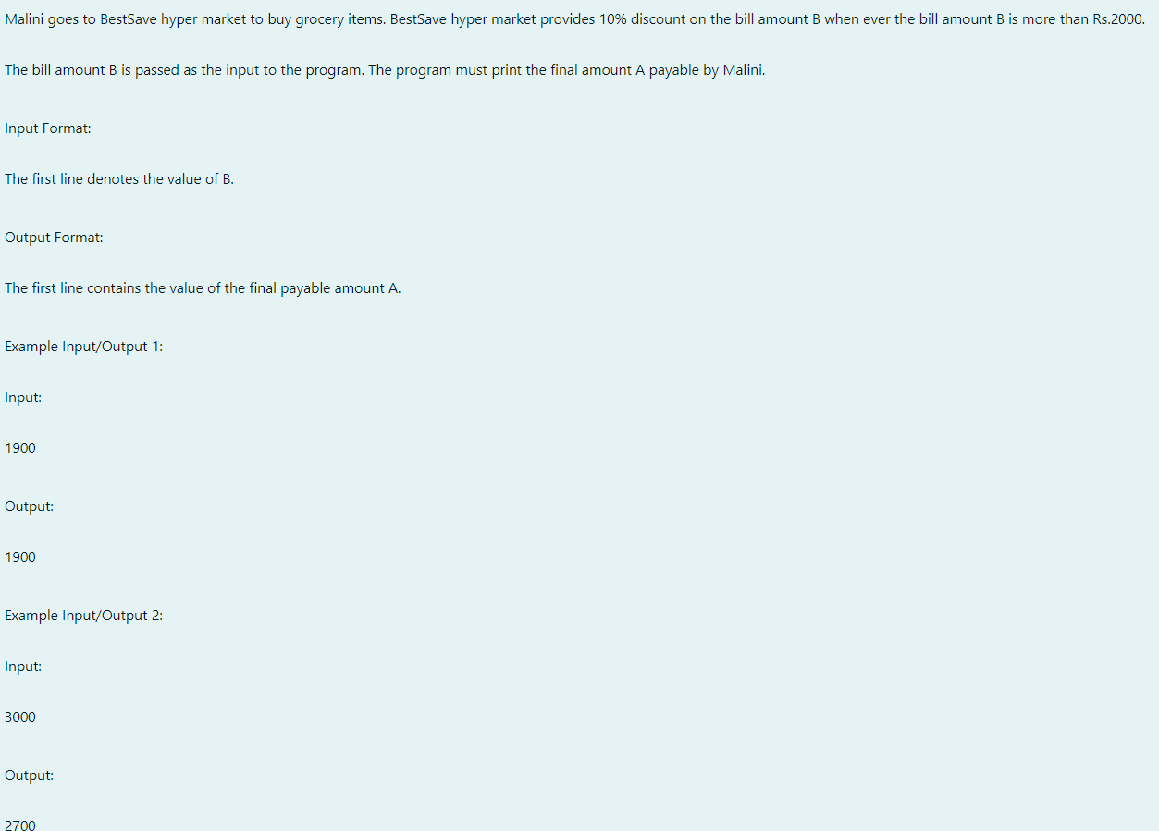

ALGORITHM:

1. Input the value B.

2. If B > 2000:

- Calculate c = 0.1 * B (10% of B).

- Calculate d = B - c (remaining amount after deduction).

- Output d.

3. Else, output B.

CODE:

#include<stdio.h>

int main()

{

int B;

scanf("%d",&B);

if(B > 2000)

{

int c,d;

c = ((0.1)*B);

d= B-c;

printf("%d",d);

}

else

{

printf("%d",B);

}

}

OUTPUT:

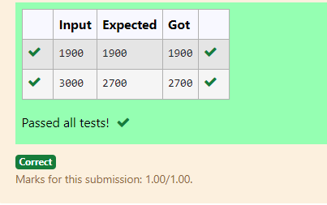

RESULT:

Thus the code is executed successfully and gives the expected output.

PROBLEM 4:

AIM:

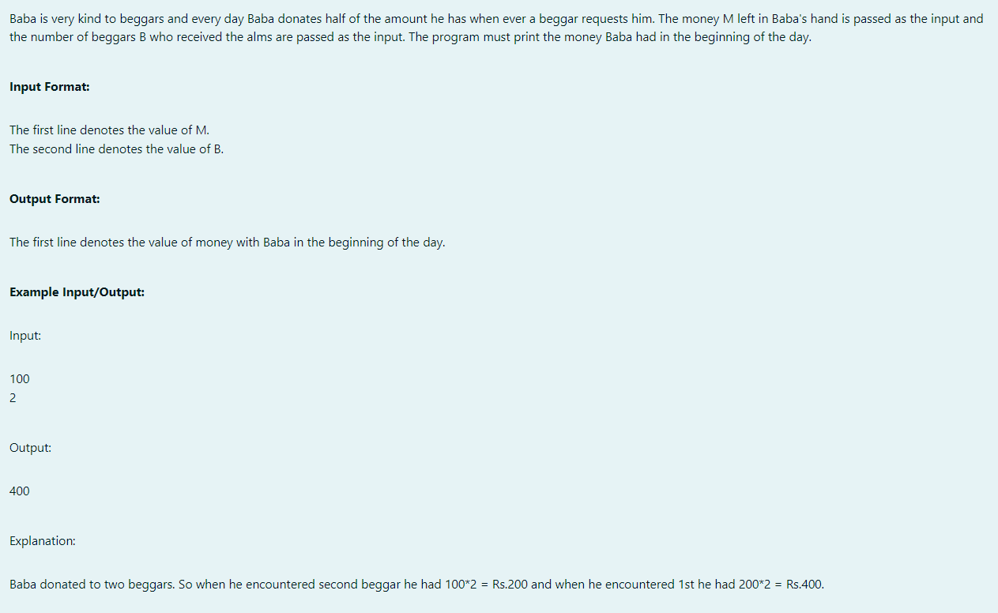

ALGORITHM:

1. Input M and B.

2. Repeat B times:

- Multiply M by 2.

3. Output M.

CODE:

#include<stdio.h>

int main()

{

int M,B;

scanf("%d",&M);

scanf("%d",&B);

int i = 0;

while(i < B)

{

M = M * 2;

i++;

}

printf("%d",M);

}

OUTPUT:

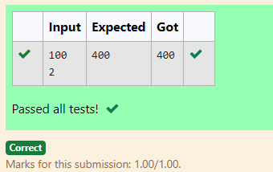

RESULT:

Thus the code is executed successfully and gives the expected output.

PROBLEM 5:

AIM:

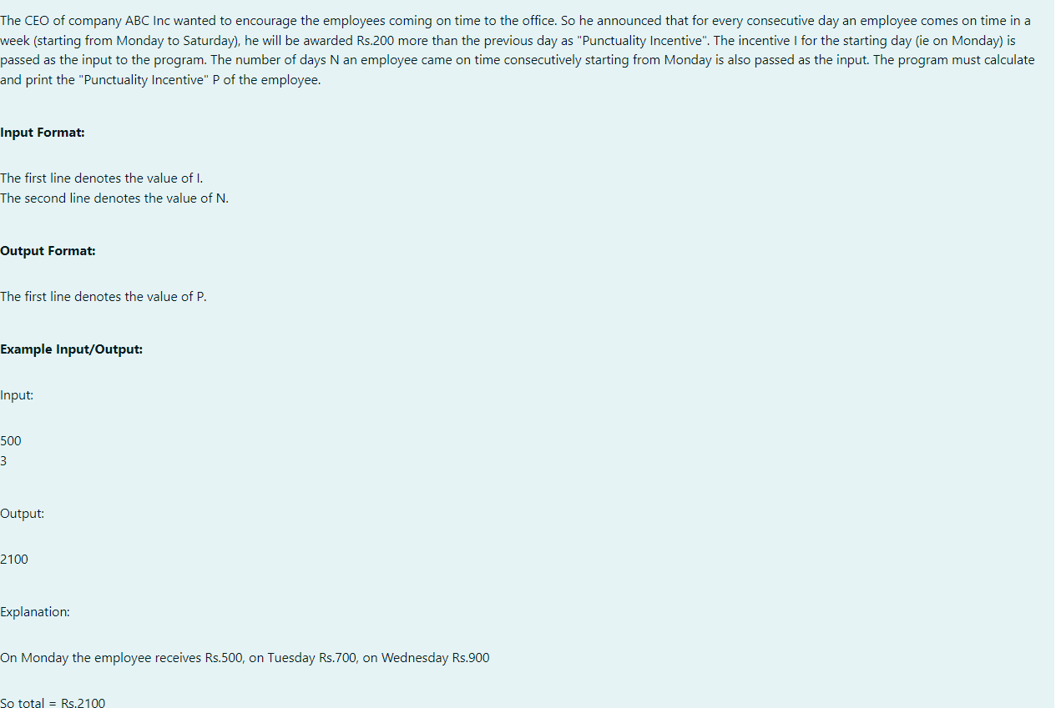

ALGORITHM:

1. Input I and N.

2. Initialize t = 0 and a = 0.

3. Repeat N times:

- Add I to t.

- Increase I by 200.

4. **Output t.

CODE:

#include<stdio.h>

int main()

{

int I,N;

int t = 0 , a = 0;

scanf("%d",&I);

scanf("%d",&N);

while(a < N)

{

t = t + I;

I = I + 200;

a++;

}

printf("%d",t);

}

OUTPUT:

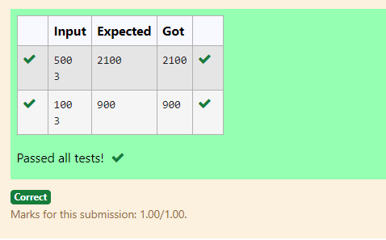

RESULT:

Thus the code is executed successfully and gives the expected output.

PROBLEM 6:

AIM: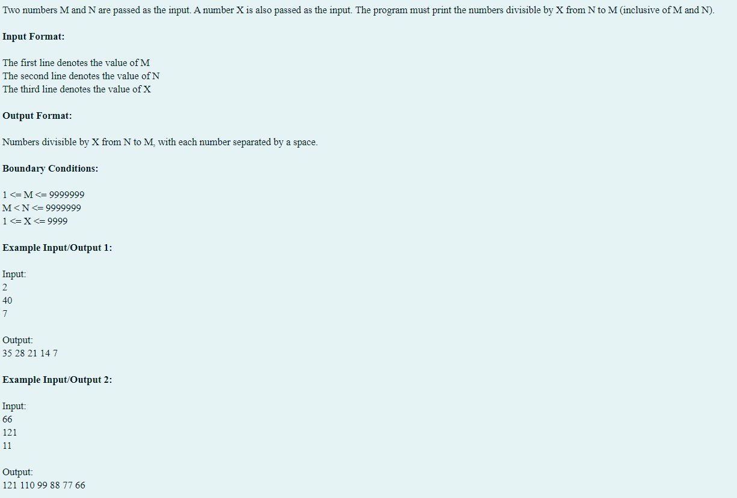

ALGORITHM:

1. Input a, b, and c.

2. Loop from b to a:

- If i % c == 0, print i.

3. End.

CODE:

#include<stdio.h>

int main()

{

int a,b,c;

scanf("%d %d %d",&a,&b,&c);

for(int i = b;i >= a;i--)

{

if(i % c == 0)

{

printf("%d ",i);

}

}

}

OUTPUT:

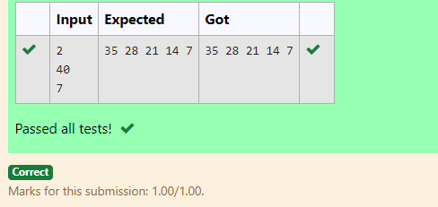

RESULT:

Thus the code is executed successfully and gives the expected output.

PROBLEM 7:

AIM:

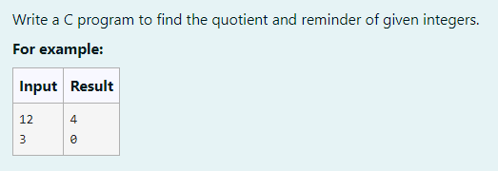

ALGORITHM:

1. Input num1 and num2.

2. Calculate the quotient: q = num1 / num2.

3. Print q.

4. Calculate the remainder: r = num1 % num2.

5. Print r.

CODE:

#include<stdio.h>

int main()

{

int num1;

int num2;

scanf("%d",&num1);

scanf("%d",&num2);

int q = num1 / num2;

printf("%d \n",q);

int r = num1 % num2;

printf("%d",r);

}

OUTPUT:

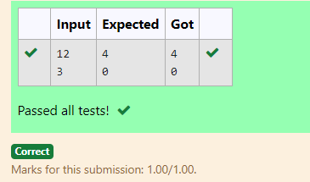

RESULT:

Thus the code is executed successfully and gives the expected output.

PROBLEM 8:

AIM:

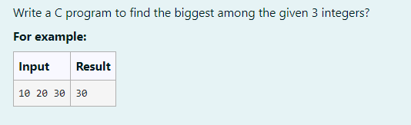

ALGORITHM:

1. Input num1, num2, and num3.

2. Compare the numbers:

- If num1 is greater than both num2 and num3, print num1.

- Else if num2 is greater than both num1 and num3, print num2.

- Else, print num3.

CODE:

#include<stdio.h>

int main()

{

int num1,num2,num3;

scanf("%d %d %d",&num1,&num2,&num3);

if(num1 > num2 && num1 > num3)

{

printf("%d",num1);

}

else if(num2 > num1 && num2 >num3)

{

printf("%d",num2);

}

else

{

printf("%d",num3);

}

}

OUTPUT:

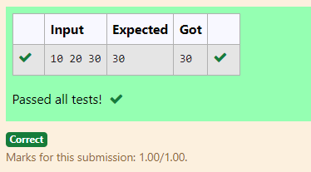

RESULT:

Thus the code is executed successfully and gives the expected output.

PROGRAM 9:

AIM:

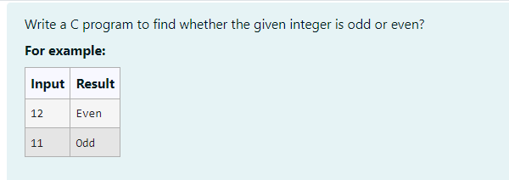

ALGORITHM:

1. Input num.

2. If num % 2 == 0:

- Print "Even".

3. Else:

- Print "Odd".

CODE:

#include<stdio.h>

int main()

{

int num;

scanf("%d",&num);

if(num % 2 == 0)

{

printf("Even");

}

else

{

printf("Odd");

}

}

OUTPUT:

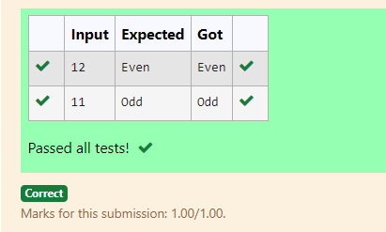

RESULT:

Thus the code is executed successfully and gives the expected output.

PROBLEM 10:

AIM:

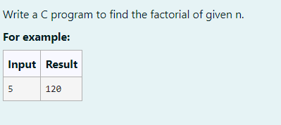

ALGORITHM:

1. Input num.

2. Initialize fact = 1.

3. Loop from i = 1 to num:

- Multiply `fact` by `i`.

4. Print fact.

CODE:

#include<stdio.h>

int main()

{

int num;

scanf("%d",&num);

int fact = 1;

for(int i = 1;i <= num;i++)

{

fact = fact * i;

}

printf("%d",fact);

}

OUTPUT:

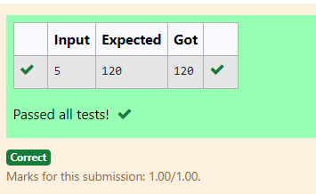

RESULT:

Thus the code is executed successfully and gives the expected output.

PROBLEM : 11

AIM:

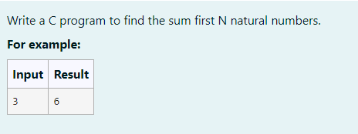

ALGORITHM:

1. Input a.

2. Initialize N = 0.

3. Loop from i = 1 to a:

- Add i to N.

4. Print N.

CODE:

#include<stdio.h>

int main()

{

int a;

scanf("%d",&a);

int N = 0;

for(int i = 1;i <= a;i++)

{

N = N + i;

}

printf("%d",N);

}

OUTPUT:

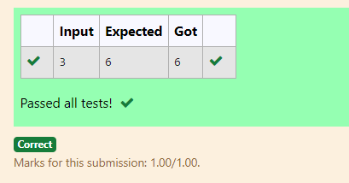

RESULT:

Thus the code is executed successfully and gives the expected output.

PROBLEM 12:

AIM:

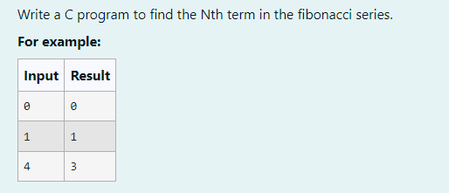

ALGORITHM:

1. Input n.

2. If n == 0, print 0.

3. If n == 1, print 1.

4. Else:

- Initialize a = 1 and b = 1.

- Loop from i = 2 to n-1:

- Calculate c = a + b.

- Set a = b and b = c.

5. Print c.

CODE:

#include<stdio.h>

int main()

{

int n;

scanf("%d",&n);

if(n==0)

{

printf("%d",0);

}

else if(n == 1)

{

printf("%d",1);

}

else

{

int a,b,c;

a=1,b=1;

for(int i = 2;i<n;i++)

{

c=a+b;

a=b;

b=c;

}

printf("%d",c);

}

}

OUTPUT:

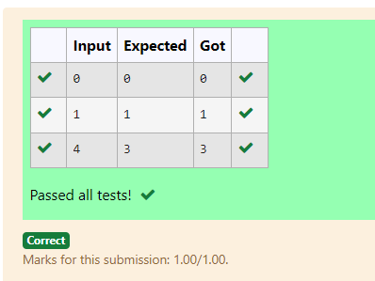

RESULT:

Thus the code is executed successfully and gives the expected output.

PROBLEM 13:

AIM:

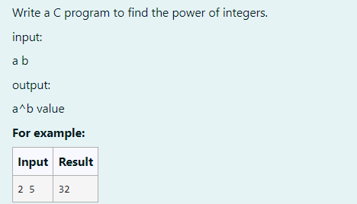

ALGORITHM:

1. Input a and b.

2. Initialize c = 1.

3. Loop from i = 1 to b:

- Multiply c by a.

4. Print c.

CODE:

#include<stdio.h>

int main()

{

int a,b,c=1,i;

scanf("%d %d",&a,&b);

for(i=1;i<=b;i++)

{

c=c*a;

}

printf("%d",c);

}

OUTPUT:

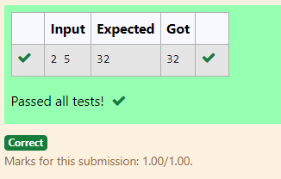

RESULT:

Thus the code is executed successfully and gives the expected output.

PROBLEM 14:

AIM:

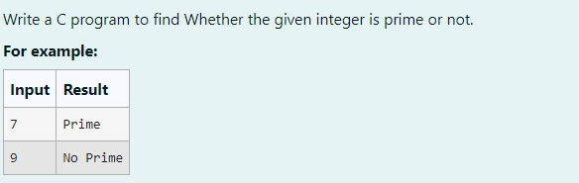

ALGORITHM:

1. Input n.

2. Initialize c = 0.

3. Loop from i = 2 to n-1:

- If n % i == 0, increment c by 1.

4. If c > 0, print "No Prime" (n is not prime).

5. Else, print "Prime" (n is prime).

CODE:

#include<stdio.h>

int main()

{

int n,i,c=0;

scanf("%d",&n);

for(i=2;i<n;i++)

{

if(n%i==0)

{

c=c+1;

}

}

if(c>0)

{

printf("No Prime");

}

else

{

printf("Prime");

}

}

OUTPUT:

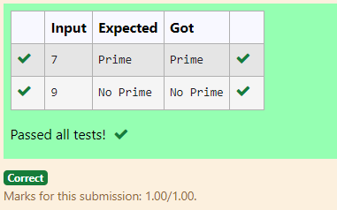

RESULT:

Thus the code is executed successfully and gives the expected output.

PROBLEM 15:

AIM:



ALGORITHM:

1. Input the number num.

2. Initialize rev = 0.

3. While num > 0:

- Calculate the remainder rem = num % 10.

- Update rev = (rev * 10) + rem.

- Update num = num / 10.

4. Output the reversed number rev.

CODE:

#include<stdio.h>

int main()

{

int num,rev=0,rem;

scanf("%d",&num);

while(num>0)

{

rem=num%10;

rev=(rev*10)+rem;

num=num/10;

}

printf("%d",rev);

}

OUTPUT:

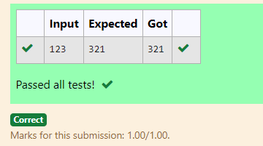

RESULT:

Thus the code is executed successfully and gives the expected output.